 | Year 12 Mathematics Essentials  Practical Application  Excavation  (Measurement)

Student Name:

Materials Allowed: | Pens, pencils, rulers, scientific (non-programmable) calculators
Time Allowed: | 50 minutes | Percentage:
 |  | Grade:

You arrive at a building construction site to discover that a trench has been dug in order to lay electrical wiring to the building. Your supervisor has tasked you with determining much it will cost to fill in the trench with soil.
You have been given the following information:

The Trench
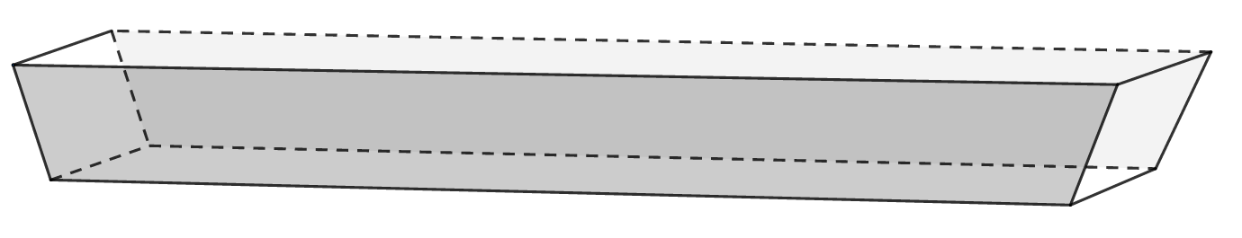
The trench is a trapezoidal prism. The width of the trench is roughly constant at 1.2 metres. The trench is 1.6 metres deep. At ground level, the trench is 36.3 metres long and at the bottom of the trench it is 33.6 metres long.

The Staff
There are eight apprentices employed to do the work. Each has their own wheelbarrow. It takes each apprentice 5 minutes to fill up a wheelbarrow with soil from the truck, transport it to the trench, empty the soil into the trench, compact the soil down and return to the truck.
Each apprentice is paid at the same hourly rate of $8.45 / hour and must be paid in full hourly intervals (no parts of an hour).

The Wheelbarrow
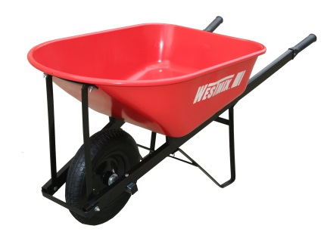
Each wheelbarrow is identical and has a capacity of 100 litres.

The Truck
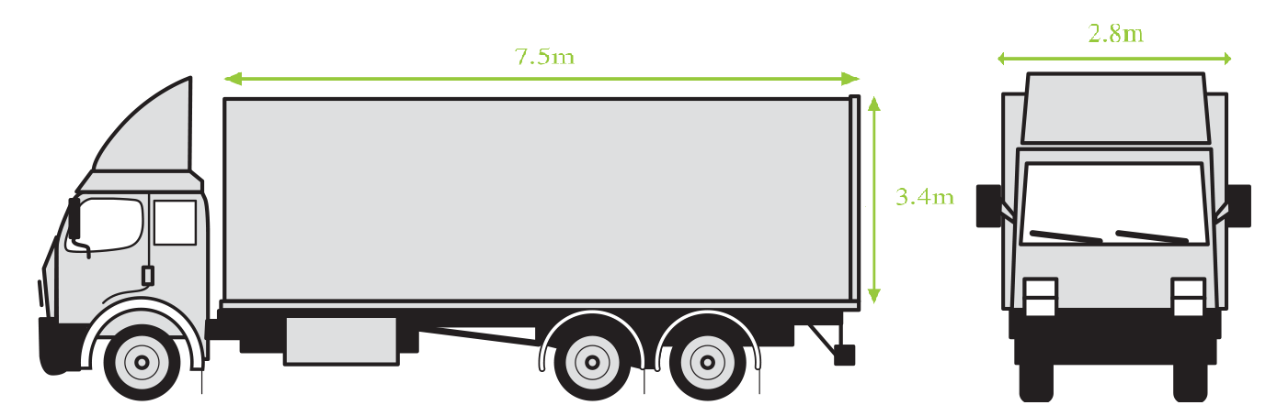

The Soil
The soil used to fill in the trench is fill sand. The cost for the fill sand including delivery is shown in the table below:
Amount | Cost
$\frac{1}{4}$ trailer load | $1000
$\frac{1}{2}$ trailer load | $1850
Full Load | $3500
The soil can only be purchased in these sizes.

The Mathematical Thinking Process
Remember, you will be marked for your use of the mathematical thinking process. That is:
- interpret the task and gather the key information
- identify the mathematics which could help to complete the task
- analyse information and data from a variety of sources
- apply their existing mathematical knowledge and strategies to obtain a solution
- verify the reasonableness of the solution
- communicate findings in a systematic and concise manner.
Ensure that you show how you are using the mathematical thinking process in your working out.

Required STEPS
Introduction:
- State the purpose of the task, including summarising the intermediate steps. Identify the key information required to determine a solution.
Task 1:
- Determine how many cubic metres of soil are required to fill in the trench.
- Determine the number of wheelbarrow trips required to fill in the trench.
- Determine the labour cost of filling in the trench.
- Determine how many cubic metres of soil will fit in the truck.
- Determine the cost of the soil.
- Determine the cost of filling in the trench.
Task 2:
- Your boss suggests that by allocating four apprentices to transporting soil and the other four to filling in the trench, then each wheelbarrow’s worth of soil would only take four minutes to transport and fill in. By what percentage would the total cost be reduced?
Conclusion:
- Write a clear and concise conclusion stating your conclusions for tasks two and three.

MARKING RUBRIC

E | D | C | B | A
Interpret the tasks and choose the maths
No statement outlining the task. | Writes a statement outlining the task. | Writes a series of statements that outline the task. | Writes a clear and concise series of statements that outline the task.  . | Uses accurate mathematical language and expressions to communicate a clear and concise series of statements that outline the task.
0 | 2 | 3 | 4 | 5
No sequence of steps. | No sequence of steps to be followed. However, the key mathematical concepts and formulae are identified. | Sequence of steps to be followed identifies the key mathematical concepts and formulae. | States or describes a sequence of steps to be followed in order to solve the problem showing the key mathematical concepts and formulae and the majority of intermediate steps. | States or describes the most efficient sequence of steps to solve the problem. Shows how the modification of the original information will affect the sequence of steps.
0 | 2 | 3 | 4 | 5
Apply mathematical knowledge to obtain a solution
/ 40

Interpret and communicate
No conclusion for first task. | Writes a series of statements that summarise the first task. | Writes a series of statements that show the result from the first task. | Writes a clear and concise conclusion addressing the result of the first task. | Uses accurate mathematical language and expressions to communicate a clear and concise conclusion addressing the result of the first task.
0 | 2 | 3 | 4 | 5
No conclusion for second task. | Writes a series of statements that summarise the second task. | Writes a series of statements that show the result from the second task. | Writes a clear and concise conclusion demonstrating how the modification in the second task changed the result in the first task. | Uses accurate mathematical language and expressions to communicate a clear and concise conclusion demonstrating how the modification in the second task changed the result in the first task.
0 | 2 | 3 | 4 | 5
Total of 60 possible marks.

ANSWERS AND MARKING KEY

Task 1
- Determine how many cubic metres of soil are required to fill in the trench.
$$Area_{trapezium}=\frac{a+b}{2}×h \\ Volume=Area×length \\ Volume_{trapezium}=\frac{a+b}{2}×h×l \\ =\frac{36.3+33.6}{2}×1.6×1.2 \\ =67.104 m^{3}$$
Determines the formula for the volume of a trapezium. | 1-2
Identifies the dimensions of the trapezoidal prism from the information given. | 1
Calculates the volume of the trench | 2
States the answer to a reasonable degree of accuracy (at least one decimal place) | 1
States the answer with the correct units. | 1
TOTAL | 7
- Determine the number of wheelbarrow trips required to fill in the trench.
$$1000L=1m^{3} \\ Volume_{wheelbarrow}=100÷1000=0.1m^{3} \\ number of trips=V_{trench}÷V_{wheelbarrow} \\ =67.104÷0.1 \\ =671.04 \\ =672 trips$$
Identifies conversion factor | 1
Converts between capacity and volume | 1
Identifies the method to determine number of trips | 1
Calculates the number of trips | 1
Rounds up to get whole number of trips | 1
TOTAL | 5
- Determine the labour cost of filling in the trench.
$$Number of trips each person=672 trips÷8 people \\ =84 trips per person \\ time taken per person=number of trips per person×time for each trip \\ =84×5 \\ =450 minutes \\ =7 hrs \\ cost of hiring each person=\$8.45×7 \\ =\$59.15 \\ cost of hiring 8 people=\$59.15×8 \\ =\$473.20$$

Determines the number of trips per person | 1
Determines the time per person in minutes | 1
Converts time to hours | 1
Determines cost of each apprentice for the task | 1
Determines cost for all 8 apprentices | 1
States answer to two decimal places with units | 1
TOTAL | 6
- Determine how many cubic metres of soil will fit in the truck.
$$V_{rectangular prism}=l×b×h \\ =7.5×2.8×3.4 \\ =71.4m^{3}$$

Identifies the formula for the volume of a rectangular prism | 1
Identifies the dimensions of the rectangular prism from the information given. | 1
Calculates the volume of soil that will fit in the truck | 2
States the answer with the correct units. | 1
TOTAL | 5
- Determine the cost of the soil.
As 71.4$m^{3}$ is more than the amount required, but a half load of 35.7$m^{3}$ is not enough, 1 full truck load is required.
Therefore the cost is $3500.

Identifies the number of truck loads | 2
Justifies their answer based on volume of trench and volume of truck | 1
States the cost | 1
TOTAL | 4
- Determine the cost of filling in the trench.
$$cost=labour cost+soil cost \\ =\$473.20+\$3500 \\ =\$3973.20$$

Identifies that total cost is equal to addition of labour and soil costs | 1
Calculates the total cost | 1
Gives answers to two decimal places and includes units | 1
TOTAL | 3

TASK 2
- Your boss suggests that by allocating four apprentices to transporting soil and the other four to filling in the trench, then each wheelbarrow’s worth of soil would only take four minutes to transport and fill in. By what percentage would the total cost be reduced?
Affects labour cost only. Therefore:
$$new time taken per person=84 trips×4 \\ =336 minutes \\ =5.6 hours \\ =6 hours each \\ new cost of hiring each person=\$8.45×6 \\ =\$50.70 \\ cost of hiring 8 people=\$50.70×8 \\ =\$405.60 \\ new total cost=labour cost+soil cost \\ =\$405.60+\$3500 \\ =\$3905.60 \\ difference in cost=3973.2-3905.60 \\ =\$67.60 \\ percentage reduction=\frac{\$67.60}{\$3973.20}×100 \\ =1.70\%$$

Determines new time taken per person in minutes | 1
Converts to hours and rounds appropriately | 1
Determines new cost of hiring each person | 1
Determines new cost of hiring 8 people | 1
Determines new labour cost | 1
Determines new total cost | 1
Determines difference in cost | 2
Determines percentage reduction | 2
TOTAL | 10

